EDRC Use Case 1, Test Case 1, Section 7.2.9 NPSHA
Revision of EDRC doc:

11 | Updated to reflect comments from David Price | K Willshaw  30 March 2015

Test case spec release 1.0

Template Name : IndividualHasIndirectPropertyWithValue

Role Name | Role Type | Role Value
hasPossessor | dm:PossibleIndividual | EQUIPMENT Identifier
hasIndirectPropertyType | dm:ClassOfIndirectProperty | NET POSITIVE SUCTION HEAD AVAILABLE
valPropertyValue | dm:ExpressReal | Value of Property
hasPropertyScale | dm:Scale | METRE H2O AT 4 DEGREE CELCIUS

Comments – the valPropertyValue is not an ExpressReal in this template. It is as follows: (tpl:valPropertyValue only xsd:float)

Comments – the template URI for use in the exchange file is :
http://data.posccaesar.org/tpl/IndividualHasIndirectPropertyWithValue

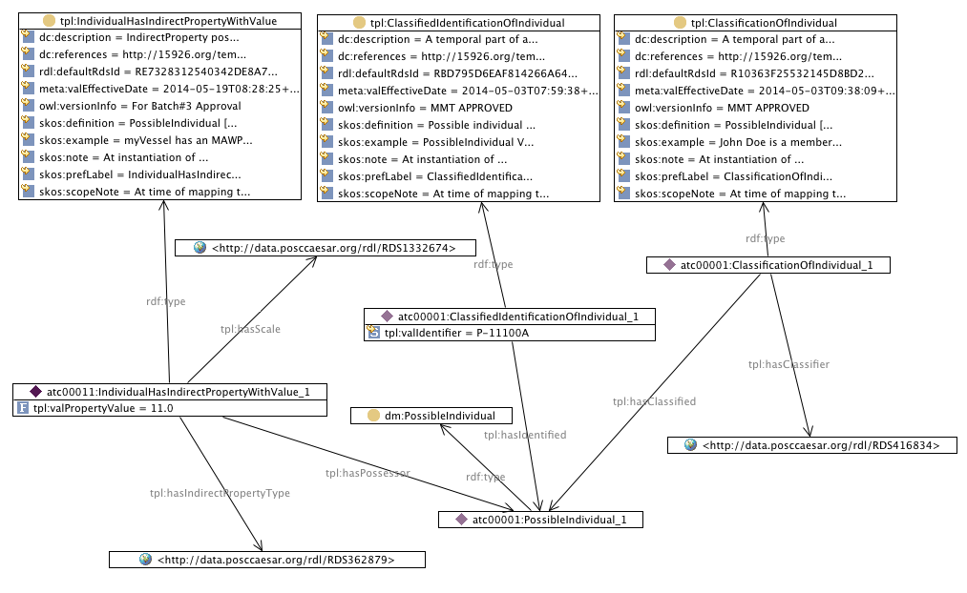

SPARQL to find Differential Head of Pump

SELECT ?PumpIdentifier ?NPSHAMetre
WHERE {
?classificationofindividual tpl:hasClassified ?possibleindividual .
?classificationofindividual tpl:hasClassifier <http://data.posccaesar.org/rdl/RDS416834> .
?classificationofindividual rdf:type tpl:ClassificationOfIndividual .
?possibleindividual rdf:type dm:PossibleIndividual .
?individualhasindirectpropertywithvalue tpl:hasIndirectPropertyType <http://data.posccaesar.org/rdl/RDS362879> .
?individualhasindirectpropertywithvalue tpl:hasPossessor ?possibleindividual .
?individualhasindirectpropertywithvalue tpl:hasScale <http://data.posccaesar.org/rdl/RDS1332674> .
?individualhasindirectpropertywithvalue rdf:type tpl:IndividualHasIndirectPropertyWithValue .
?classifiedidentificationofindividual tpl:hasIdentified ?possibleindividual .
?classifiedidentificationofindividual tpl:hasIdentificationType <http://data.posccaesar.org/rdl/RDS2100944981> .
?classifiedidentificationofindividual rdf:type ?class .
?individualhasindirectpropertywithvalue tpl:valPropertyValue ?NPSHAMetre.
?classifiedidentificationofindividual tpl:valIdentifier ?PumpIdentifier .
}

